√ **Sit – Seat**

*To sit is to rule and judge*

**John 8:1-12** Jesus went unto the mount of Olives. And early in the morning he came again into the temple, and all the people came unto him; and he sat down, and taught them. And the scribes and Pharisees brought unto him a woman taken in adultery; and when they had set her in the midst, they say unto him, Master, this woman was taken in adultery, in the very act. Now Moses in the law commanded us, that such should be stoned: but what sayest thou? This they said, tempting him, that they might have to accuse him. But Jesus stooped down, and with *his* finger wrote on the ground, *as though he heard them not.* So, when they continued asking him, he lifted up himself, and said unto them, He that is without sin among you, let him first cast a stone at her. And again, he stooped down, and wrote on the ground. And they which heard *it,* being convicted by *their own* conscience, went out one by one, beginning at the eldest, *even* unto the last: and Jesus was left alone, and the woman standing in the midst. When Jesus had lifted up himself, and saw none but the woman, he said unto her, Woman, where are those thine accusers? hath no man condemned thee? She said, No man, Lord. And Jesus said unto her, neither do I condemn thee: go, and sin no more. Then spake Jesus again unto them, saying, I am the light of the world: he that followeth me shall not walk in darkness, but shall have the light of life.

**Mat 24:3** And as he sat upon the mount of Olives, the disciples came unto him privately, saying, tell us, when shall these things be? and what *shall be* the sign of thy coming, and of the end of the world?

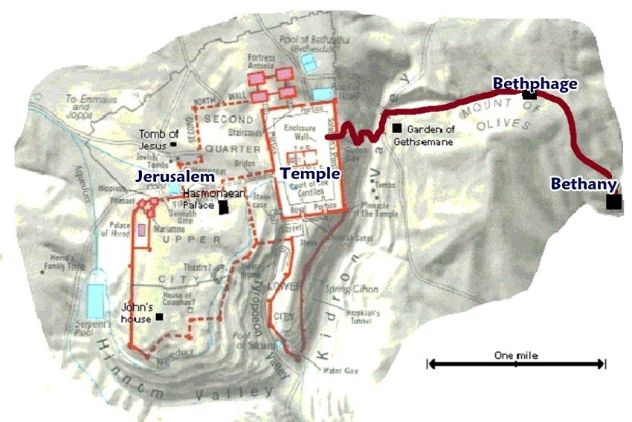Mark 13:3-5 And as he sat upon the **mount of Olives** over against the temple, Peter and James and John and Andrew asked him privately, Tell us, when shall these things be? and what *shall be* the sign when all these things shall be fulfilled? And Jesus answering them began to say, Take heed lest any *man* deceive you:

**Mat 21:1-6** And when they drew nigh unto Jerusalem, and were come to Bethphage, unto the mount of Olives, then sent Jesus two disciples, saying unto them, go into the village over against you, and straightway ye shall find an ass tied, and a colt with her: loose *them,* and bring *them* unto me. And if any *man* say ought unto you, ye shall say, The Lord hath need of them; and straightway he will send them. All this was done, that it might be fulfilled which was spoken by the prophet, saying, tell ye the daughter of Sion, Behold, thy King cometh unto thee, meek, and sitting upon an ass, and a colt the foal of an ass. And the disciples went, and did as Jesus commanded them,

Ezek 28:2 Son of man, say unto the prince of Tyrus, thus saith the Lord GOD; Because thine heart *is* lifted up, and thou hast said, I *am* a God, I sit *in* the seatof God, in the midst of the seas; yet thou *art* a man, and not God, though thou set thine heart as the heart of God:

Mat 23:1-2 Then spake Jesus to the multitude, and to his disciples, Saying, the scribes and the Pharisees sit in Moses' seat: All therefore whatsoever they bid you observe, *that* observe and do; but do not ye after their works: for they say, and do not. 4For they bind heavy burdens and grievous to be borne, and lay *them* on men’s shoulders; but they *themselves* will not move them with one of their fingers. 5But all their works they do for to be seen of men: they make broad their phylacteries, and enlarge the borders of their garments, 6And love the uppermost rooms at feasts, and the chief seats in the synagogues, 7And greetings in the markets, and to be called of men, Rabbi, Rabbi. 8But be not ye called Rabbi: for one is your Master, *even* Christ; and all ye are brethren. 9And call no *man* your father upon the earth: for one is your Father, which is in heaven. 10Neither be ye called masters: for one is your Master, *even* Christ. 11But he that is greatest among you shall be your servant. 12And whosoever shall exalt himself shall be abased; and he that shall humble himself shall be exalted.

John 19:10-13 Then saith Pilate unto him, Speakest thou not unto me? knowest thou not that I have power to crucify thee, and have power to release thee? Jesus answered, thou couldest have no power *at all* against me, except it were given thee from above: therefore, he that delivered me unto thee hath the greater sin. And from thenceforth Pilate sought to release him: but the Jews cried out, saying, If thou let this man go, thou art not Caesar's friend: whosoever maketh himself a king speaketh against Caesar. When Pilate therefore heard that saying, he brought Jesus forth, and sat down in the judgment seatin a place that is called the Pavement, but in the Hebrew, Gabbatha.

Acts 25:1-6 Now when Festus was come into the province, after three days he ascended from Caesarea to Jerusalem. Then the high priest and the chief of the Jews informed him against Paul, and besought him, and desired favour against him, that he would send for him to Jerusalem, laying wait in the way to kill him. But Festus answered, that Paul should be kept at Caesarea, and that he himself would depart shortly *thither.* Let them therefore, said he, which among you are able, go down with *me,* and accuse this man, if there be any wickedness in him. And when he had tarried among them more than ten days, he went down unto Caesarea; and the next day sitting on the judgment seatcommanded Paul to be brought.

Acts 25:9-12 But Festus, willing to do the Jews a pleasure, answered Paul, and said, wilt thou go up to Jerusalem, and there be judged of these things before me? Then said Paul, I stand at Caesar's judgment seat**,** where I ought to be judged: to the Jews have I done no wrong, as thou very well knowest. For if I be an offender, or have committed any thing worthy of death, I refuse not to die: but if there be none of these things whereof these accuse me, no man may deliver me unto them. I appeal unto Caesar. Then Festus, when he had conferred with the council, answered, Hast thou appealed unto Caesar? unto Caesar shalt thou go.

Rom 14:8-13 For whether we live, we live unto the Lord; and whether we die, we die unto the Lord: whether we live therefore, or die, we are the Lord's. For to this end Christ both died, and rose, and revived, that he might be Lord both of the dead and living. But why dost thou judge thy brother? or why dost thou set at nought thy brother? for we shall all stand before the judgment seatof Christ.

Rev 2: 13 And to the angel of the church in Pergamos write; These things saith he which hath the sharp sword with two edges; I know thy works and where thou dwellest, *even* where Satan's seat*is:* and thou holdest fast my name, and hast not denied my faith, even in those days wherein Antipas *was* my faithful martyr, who was slain among you, where Satan dwelleth.

Rev 13:1-2 And I stood upon the sand of the sea, and saw a beast rise up out of the sea, having seven heads and ten horns, and upon his horns ten crowns, and upon his heads the name of blasphemy. And the beast which I saw was like unto a leopard, and his feet were as *the feet* of a bear, and his mouth as the mouth of a lion: and the dragon gave him his power, and his seat**,** and great authority.